**Title:** Study of Transistor Characteristics in Common Emitter Amplifier

**Introduction:**

A BJT is a three terminal semiconductor device. It is widely used in discrete circuits as well as in integrated circuits. The main applications of BJTs are analog circuits. For example, BJTs are used for amplifiers in particular for high speed amplifiers. BJTs can be used for digital circuits as well, but most of the digital circuits are nowadays realized by field effect transistors (FETs). There are three operating modes for BJTs, the active mode (amplifying mode), the cut-off mode and the saturation mode. To apply a BJT as an amplifier, the BJT has to operate in the active mode. To apply a BJT as a digital circuit element, the BJT has to operate in the cut-off mode and the saturation mode.

The main objectives of this experiment are to-

1. become familiar with bipolar junction transistors (BJTs)
2. study the biasing of a Common Emitter (CE) Amplifier, and
3. obtain the input and output characteristics of a common-emitter based BJT circuits.

**Theory and Methodology:**

# Device structure of bipolar junction transistors

Each BJT consists of two anti serial connected diodes. The BJT can be either implemented as an npn or a pnp transistor. In both cases, the center region forms the base (B) of the transistor, while the external regions form the collector (C) and the emitter (E) of the transistor. External wire connections to the p and n regions (transistor terminals) are made through metal (e.g.

Aluminum) contacts.

A cross section of the two types of BJTs consisting of an emitter-base junction and a collectorbase junction is shown in the figure below. An npn or a pnp transistors are called bipolar transistors because both types of carriers (electrons and holes) contribute to the overall current. In the case of a field effect transistor, either the electronics or the holes determine the current flow. Therefore a field effect transistor is a unipolar device. The current and voltage amplification of a BJT is controlled by the geometry of the device (for example width of the base region) and the doping concentrations in the individual regions of the device. In order to achieve a high current amplification, the doping concentration in the emitter region is typically higher than that of the base region. The base is a lightly doped very thin region between the emitter and the collector and it controls the flow of charge carriers from the emitter to collector region.

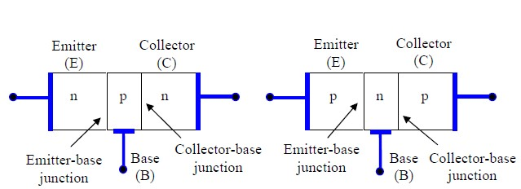

**Circuit Configuration:**

The following figures show the symbol for the npn transistor and pnp transistor. The emitter of the BJT is always marked by an arrow, which indicates whether the transistor is an npn or a pnp transistor.

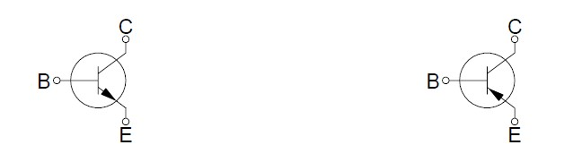

# npn BJT symbol pnp BJT symbol

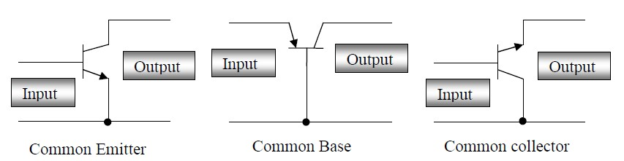

There are three basic ways in which a BJT can be configured. In each case, one terminal is common to both the input and output circuit shown in figure above.

1. The common emitter configuration is used for voltage and current amplification and is the most common configuration for transistor amplifiers.
2. The common collector configuration often called an emitter follower, since its output is taken from the emitter resistor. It is useful as an impedance matching device since its input impedance is much higher than its output impedance.
3. The common base configuration is used for high frequency applications because the base separates the input and output, minimizing oscillations at high frequency. It has a high voltage gain, relatively low input impedance and high output impedance compared to the common collector.

**Biasing of Bipolar Junction Transistors:**

In most of the cases, the BJT is used as an amplifier or switch. In order to perform these functions, the transistor must be correctly biased. Depending on the bias condition (forward or reverse) of each of the BJT junctions, different modes of operation of the BJT are obtained. The three mode are defined as follows:

1. **Active**: Emitter junction is forward biased, collector junction is reverse biased. The BJT operates in the active mode and the BJT can be used as an amplifier.
2. **Saturation**: Both the emitter and collector junctions are forward biased. If the BJT is used as a switch, the saturation mode corresponds to the on state of the BJT.
3. **Cut-off**: Both the emitter and collector junction are reverse biased. If theBJT is used as a switch, the cut-off mode corresponds to the off state of theBJT.

**Input and Output Characteristics:**

The input characteristics curves are plotted between IB and VBE keeping the voltage, VCE, constant. The input characteristics look like the characteristics of a forward-biased diode. The base-to-emitter voltage varies only slightly. The input dynamic resistance is calculated from the ratio of the small change of base-to-emitter voltage to the small change of base current.

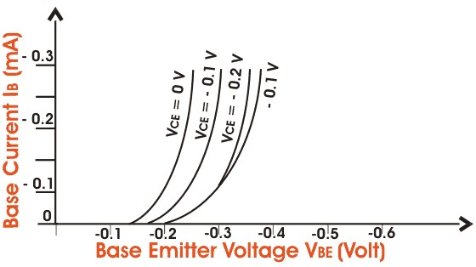

Fig: BJT Common Emitter Input Characteristics

The output characteristics curves are plotted between the collector current, IC, and the collectorto-emitter voltage drop by keeping the base current, IB, constant. These curves are almost horizontal. The output dynamic resistance again can be calculated from the ratio of the small change of emitter-to-collector voltage drop to the small change of the collector current.

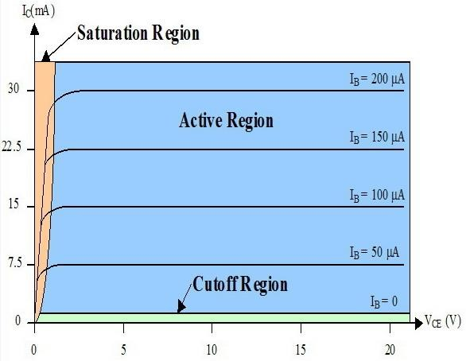

Fig: BJT Common Emitter Output Characteristics

|  |  |  |  |  |
| --- | --- | --- | --- | --- |
| **Apparatus:** |  |  |  |  |
|  |  |  |  |  |
| 1) | Trainer Board | : |  |  |
| 2) | Transistor | : | C828 | [ 1pc ] |
| 3) | Resistors | : | 1KΩ | [ 1pc ] |
|  |  |  | 10KΩ | [ 1pc ] |
| 4) | DC Power Supply |  |  |  |
| 5)  6) | Multimeter  Power Supply Cable | : |  | [ 2pc] |

**Circuit Diagram:**

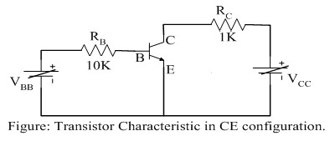

**Simulation and Measurement:**

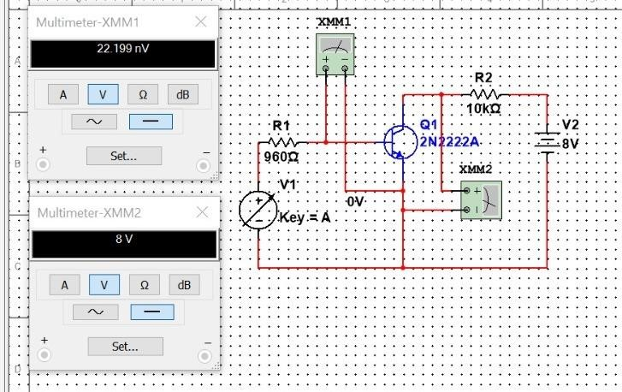

Figure 1: VBB =0 , Vcc =8v

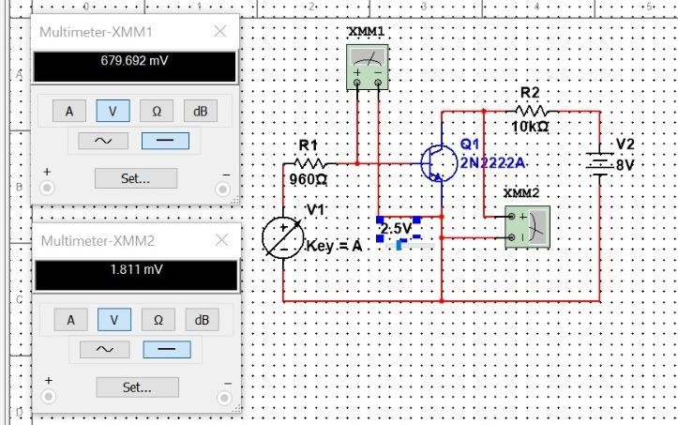

Figure 2: VBB =2.5, Vcc =8v

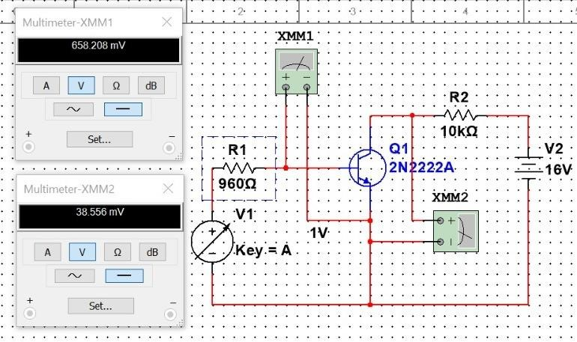

Figure 3: VBB =1, Vcc =16v

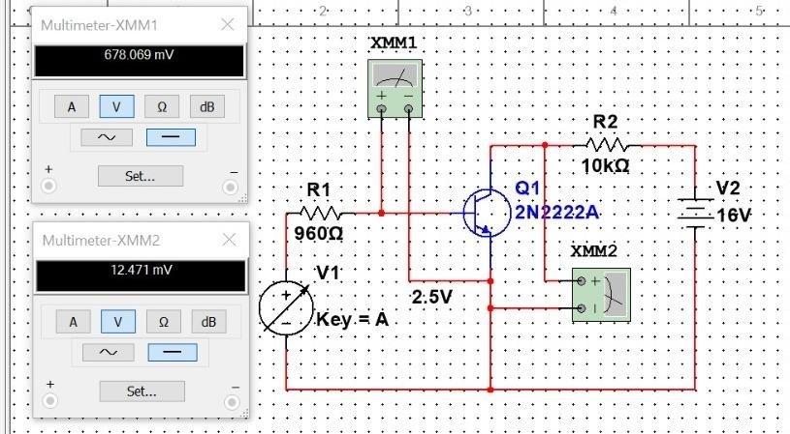

Figure 4: VBB =2.5, Vcc =16v

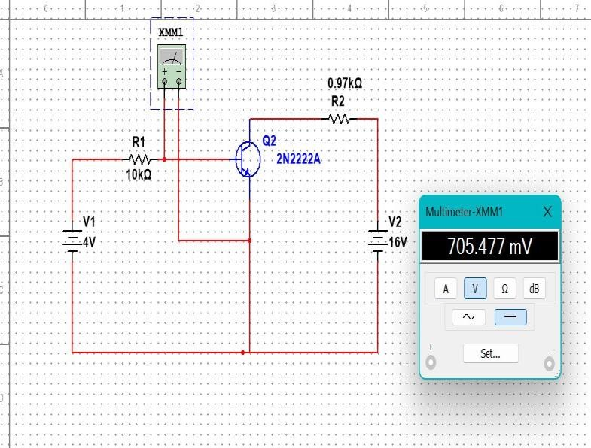

Figure 5: VBB =2, Vcc =16v

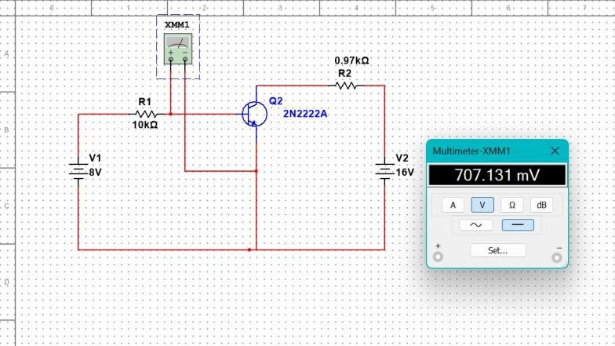

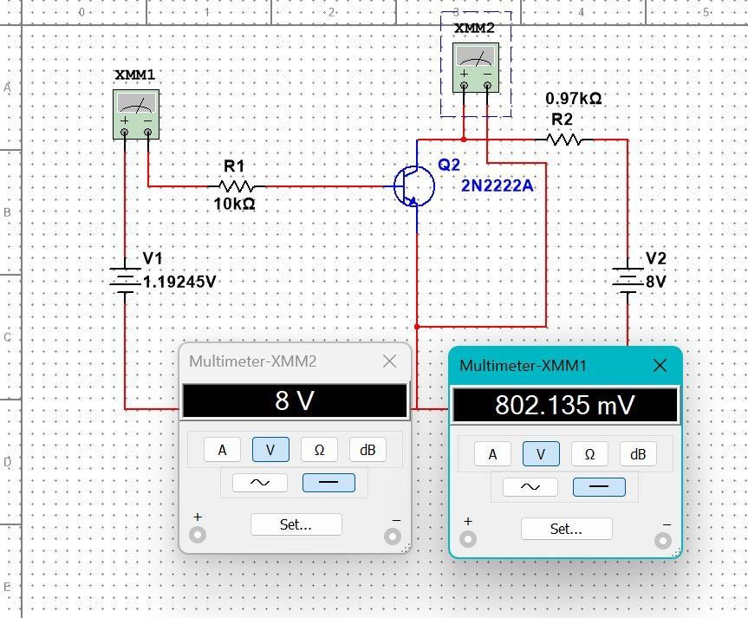

Figure 5: VBB =8V

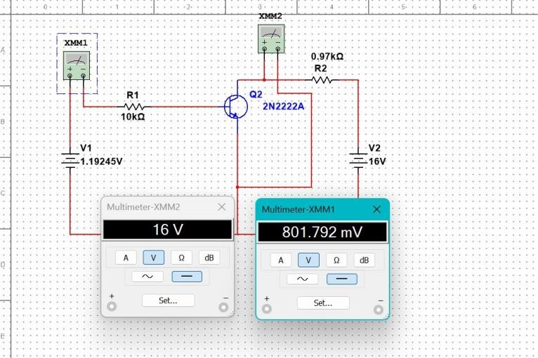

Figure 5: VBB =16V